|  |  |
| --- | --- |
| No. of Pages | **6** |
| No. of Questions | 7 |

**Department of Computer Science and Engineering**

**FINAL EXAMINATION SUMMER 2017**

**CSE421/EEE 465: Computer Networks**

**Total Marks: 100 Time Allowed: 2.5 Hours**

* Answer **Any** **Five (5)** questions out of **Seven (7)** questions.
* Figure in bracket [] next to each question indicates marks for that question.

###### Question No. 1

1. What are the characteristics of SPF algorithm and in which routing protocol it is used?

[3 +2=5 marks]

1. Why do we propagate the default route in RIP? What is Administrative Distance in routing protocol give an example? [2+2=4 marks]
2. A serial link is operates at 1.544 mbps. The bandwidth and cost commands are not used. What will be the calculated OSPF cost for the link? [3 marks]
3. Considering the topology given in figure no.1, how we can determine the router ID for the given routers? Here, we have not configured Router IDs explicitly or loopback interfaces on our three routers so what should be the criteria other than these two to determine router ID?

[4 marks]

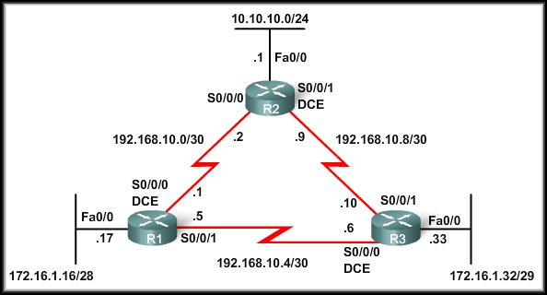

**Figure no. 1**

1. Write down the difference between RIPv1 and RIPv2. [4 marks]

###### Question No. 2

1. Write down the differences between IPv4 and IPv6 Packet Header. [4 marks]
2. Why do we fragment data in IPv4? And what fields in the IPv4 header are used for fragmentation? [3+2=5 marks]
3. What is ICMP in IPv4? Write down some of the types of ICMP error reporting messages.

[3+2=5marks]

1. Define the following attacks. [2x3=6 marks]
2. ICMP PING flood attack
3. ICMP Smurf

###### Question No. 3

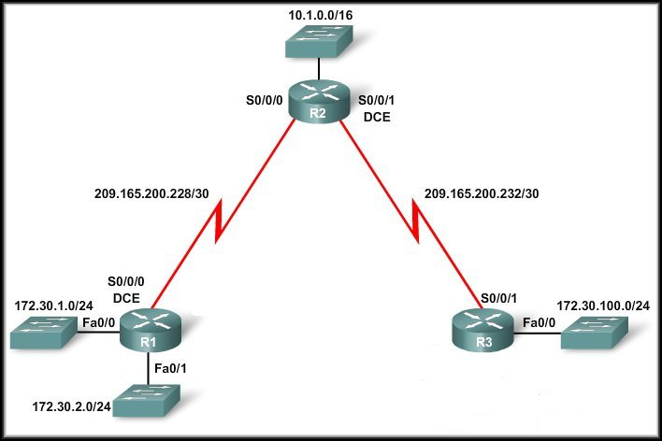

**Figure no. 2**

1. **Figure no. 2** shows a dis-contiguous network for routers running RIP. Why should we disable the auto summarization? How do we will disable the auto-summary? What if the routers were running ospf, then should we disable auto summarization?

[2+2+2=6 marks]

1. Why do we use passive interfaces? Can a serial interface of a router be passive?

[3+2=5 marks]

1. What parameters need to match for routers to be neighbors in the OSPF process?

[3 marks]

1. What is Link state routing? Write down the five step process for link state routing.

[1+5=6 marks]

###### Question No. 4

1. What are public and private addresses? Give examples. [3 marks]
2. What is NAT? And how does it work? “NAT does not provide any security”, yes or no, justify your answer. [1+4+2=7 marks]
3. When do we need static mapping in NAT? [2 marks]
4. If a network administrator wants to exclude a range of address from an address pool in DHCP what is the process? Why do we need to exclude addresses in DHCP?

[2+2=4marks]

1. What is DHCP relay? How it works? [2+2=4 marks]

###### Question No. 5

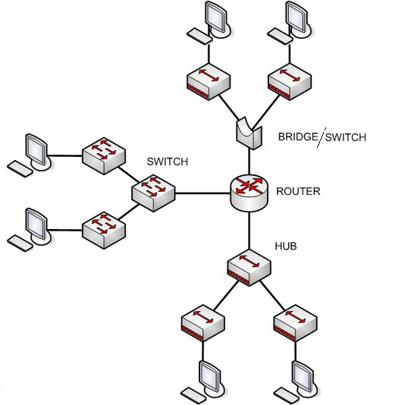

**Figure No. 3**

1. Refer to the above figure no. 3, how many collision domains and broadcast domains are available? If switches replace the hubs, will there be any change in the numbers then? [3 marks]
2. Layer 3 Switches and Routers both perform routing functions, then how are they different? [3 marks]
3. Refer to the figure no. 4 below. The switch’s VTY lines have been properly configured with the password “cisco”, but the network administrator at PC1 is unable to telnet into the switch shown. [3.5+3 marks]
   1. What can the problem and how can it be resolved?
   2. What is this ‘interface vlan 1’?

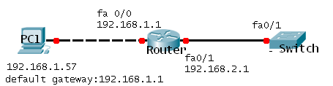

Switch(config)# interface vlan 99

Switch(config-if)# ip address 192.168.2.5 255.255.255.0

Switch(config-if)# no shutdown

Switch(config)#interface fa0/1

Switch(config-if)# switchport mode access

Switch(config-if)# switchport access vlan 99

**Figure No. 4**

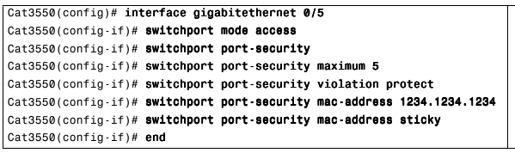

**Figure No. 5**

1. Refer to the output shown in figure no. 5 and answer the following questions. [4.5+3 marks]
   1. Explain briefly the commands written from line 3 -7.
   2. Five PCs (including the PC containing mac-address 1234.1234.1234) connected to this interface g0/5. An outsider turns the switch off and on again. Then he connects his laptop to the port and tries to send data, will he be able to or not, explain?

###### Question No. 6

###### 

1. An organization has three floors of office space in a building. Each floor has PCs belonging to four different VLANs. The staffs of this organization are not very mobile; they have their own fixed cubicles. Which method of VLAN assignment in switches will be more efficient here, static or dynamic? Why? [3 marks]

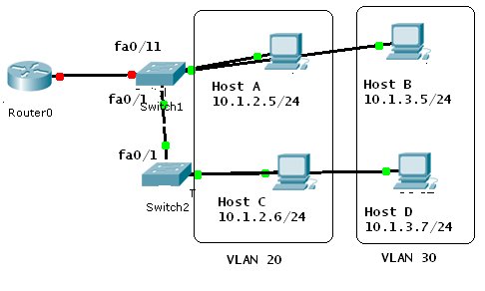

Switch 1# show interfaces trunk

Port Mode Encapsulation Status Native vlan

Fa0/1 desirable 802.1q trunking 10

Port Vlan allowed on trunk

Fa0/1 1-20,30,40

Switch 2# show interfaces trunk

Port Mode Encapsulation Status Native vlan

Fa0/1 desirable 802.1q trunking 100

Port Vlan allowed on trunk

Fa0/1 10,30,40

**Figure No. 6**

1. Refer to the figure no 6 above. The devices in the network are operational and configured as indicated. However, there is no connectivity between any of the hosts. Host C cannot ping Host A or Host B. Identify the problems and provide the solutions. (At least three problems) [4.5 marks]
2. We must not keep default VLAN as management VLAN , why? And if we do then what kind of problem can be created by a hacker? [2+2.5 marks]

R(config)#interface f0/0.8

R(config-subif)#encapsulation dot1q 44

R(config-subif)#ip add 192.168.44.100 255.255.255.224

R(config-subif)#interface f0/0.9

R(config-subif)#encapsulation dot1q 55

R(config-subif)#ip add 192.168.55.164 255.255.255.224

R(config-subif)# interface f0/0

R(config-if)#shutdown

**Figure No. 7**

1. Refer to figure no. 7. What kind of inter VLAN routing does the above commands represent? The sub-interface numbers do not match with the vlan numbers 44 and 55. Will it be a problem? Are there any other problems in the command? [1+3+2 marks]
2. What kind of switches and interfaces do we use for inter VLAN routing? [2 marks]

###### Question No. 7

1. In IPv6 there is no fragmentation, so when a router receives a packet that is larger than the MTU of the router’s interface, it will have to drop the packet. So the packet never reaches the destination. Is that so? Explain. [4 marks]
2. Explain the purpose of Unspecified IPv6 address and Link Local IPv6 address. [4 marks]
3. 2001::802:A34D:: , is an IPv6 in correct form, true or false. [2 marks]

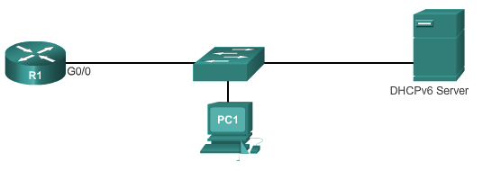

**Figure No. 8**

1. Draw the process of stateless DHCPv6 process using the figure no. 8 shown above. [5 marks]
2. In DHCPv6 both the DHCP server and the client checks that the IPv6 address given is not used by another device? How? [5 marks]

##### THE END